***Prompt 1: create 10 exclusive names for Luxury Hotels and Resorts in Lagos, Nigeria***

**Here are 10 exclusive names tailored for luxury hotels and resorts in Lagos, Nigeria, reflecting sophistication, culture, and the coastal charm of the city:**

1. **Victoria Crest Resort**
2. **Lagoon Sapphire Retreat**
3. **Eko Luxe Haven**
4. **The Atlantic Opulence**
5. **Golden Palms Lagos**
6. **Pearl Horizon Suites**
7. **Ivory Coast Sanctuary**
8. **The Emerald Lagos**
9. **Azure Marina Escape**
10. **The Coral Cove Lagos**

**These names aim to evoke a sense of exclusivity while connecting to the vibrant and coastal essence of Lagos. Let me know if you'd like adjustments or a specific theme!**

***Prompt 2: create a description for Pearl Horizon Suites and brand as a Luxury hotel***

**Pearl Horizon Suites – The Pinnacle of Luxury and Elegance**

*Nestled in the heart of [location], Pearl Horizon Suites redefines luxury, offering an unparalleled blend of sophistication, comfort, and world-class service. Designed for the discerning traveler, our hotel embodies timeless elegance with a modern twist, ensuring every moment of your stay is an unforgettable experience.*

*Each suite is a sanctuary of opulence, adorned with exquisite furnishings, premium linens, and floor-to-ceiling windows that reveal breathtaking views of [specific natural or urban features]. State-of-the-art amenities, from smart room technology to spa-inspired bathrooms, cater to your every need, blending functionality with indulgence.*

*Indulge in culinary excellence at our fine-dining restaurants, where award-winning chefs craft gourmet dishes inspired by global flavors. Unwind at our rooftop infinity pool, basking in panoramic vistas, or rejuvenate at our world-class spa, offering a curated selection of treatments designed to refresh mind, body, and soul.*

*Our commitment to personalized service ensures your every whim is anticipated, whether it’s a bespoke itinerary crafted by our concierge or a private chauffeured experience.*

*Pearl Horizon Suites is more than a hotel; it’s a lifestyle—a destination where luxury knows no bounds. Experience the extraordinary, only at Pearl Horizon Suites.*

**Prompt 3: Create a Logo of the Pearl Horizon Suites and a slogan.**

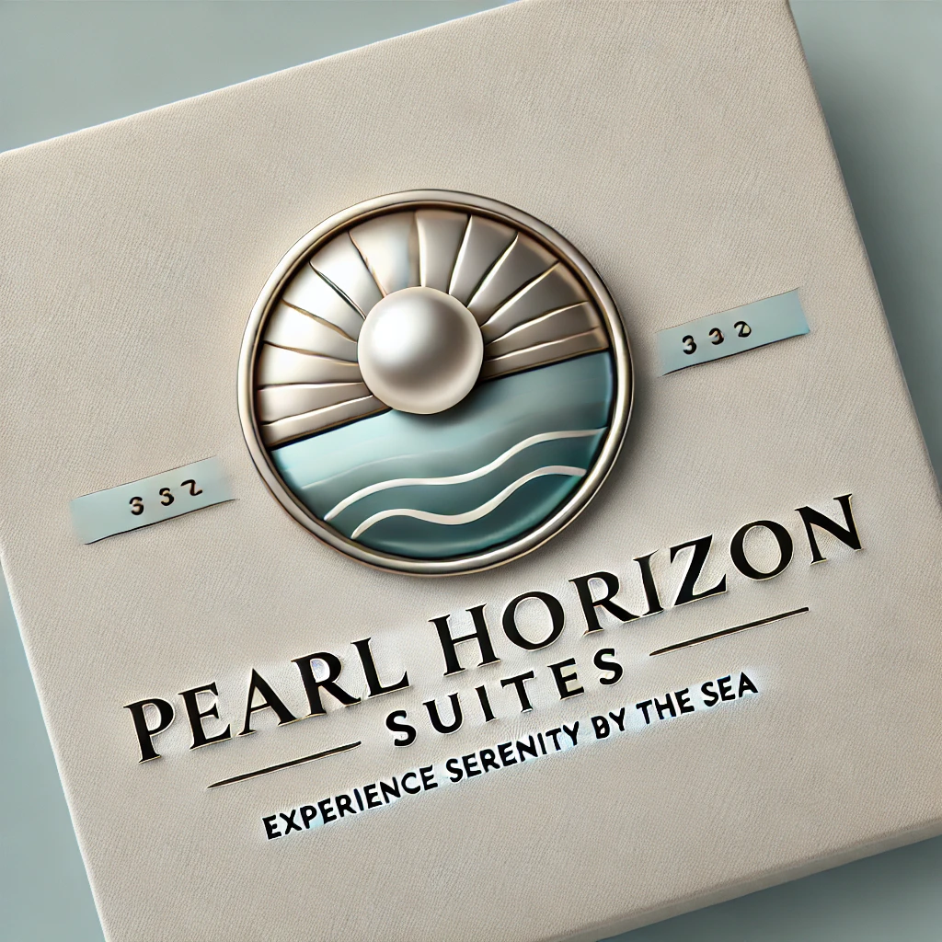

Here is a logo for the Pearl Horizon Suites with the slogan "Experience Serenity by the Sea." Let me know if you'd like any adjustments!

***Prompt 4: Create a marketing plan for Pearl Horizon suites with charts and graph***

To create a marketing plan for **Pearl Horizon Suites**, a luxury hotel or serviced apartment brand, we can break down the plan into several key components. The strategy will aim to position the suites as a premium offering for both short-term and long-term stays, targeting business professionals, tourists, and long-term tenants.

### **Marketing Plan Outline for Pearl Horizon Suites:**

1. **Market Research & Analysis**
   * **Target Audience**:
     + **Business Travelers**: Corporate executives, conference attendees, and business partners.
     + **Tourists**: Leisure travelers, international visitors, families on vacation.
     + **Long-term Stays**: People relocating, expats, digital nomads.
   * **Competitor Analysis**:
     + Identify key competitors in the region: luxury hotels, serviced apartments, Airbnb-style properties.
     + Competitive advantage: Location, amenities, high-quality service, flexible leasing options.
2. **Unique Selling Proposition (USP)**
   * **Luxury with Flexibility**: High-end amenities with the flexibility of long-term or short-term stays.
   * **Exceptional Service**: Personalized concierge services, state-of-the-art facilities (spa, gym, pool).
   * **Prime Location**: Centralized in business hubs or tourist hotspots.
   * **Sustainability Focus**: Eco-friendly initiatives, energy-efficient buildings, sustainable luxury.
3. **Marketing Objectives**
   * Increase brand awareness.
   * Drive direct bookings (through the website and mobile app).
   * Achieve a 15% increase in occupancy rate over the next 12 months.
   * Establish Pearl Horizon Suites as a preferred choice for business and leisure travelers.
   * Enhance customer loyalty and retention through personalized services.
4. **Marketing Strategies**
   * **Digital Marketing**: SEO, paid social media ads, Google Ads, and retargeting campaigns to reach potential customers.
     + Focus on platforms like LinkedIn (business professionals) and Instagram (travelers and luxury seekers).
   * **Website Optimization**: Design a mobile-responsive, user-friendly website with an easy booking process, customer testimonials, and detailed service offerings.
   * **Social Media**: Content showcasing the luxury experience, customer stories, and local attractions. Use influencers and bloggers in the travel and luxury niches.
   * **Email Marketing**: Regular newsletters with offers, special promotions, and updates about Pearl Horizon Suites.
   * **Partnerships & Collaborations**: Partner with event organizers, corporate offices, and travel agencies to promote long-term stays and corporate packages.
5. **Tactics & Action Plan**
   * **Month 1-3**:
     + Website redesign and SEO overhaul.
     + Initiate Google Ads and social media ad campaigns.
     + Launch influencer collaboration on Instagram.
   * **Month 4-6**:
     + Attend and sponsor relevant business and travel conferences to increase brand visibility.
     + Implement referral programs for long-term stays and corporate clients.
   * **Month 7-12**:
     + Host VIP events and create partnerships with local attractions.
     + Leverage guest reviews and user-generated content to build trust.
6. **Budget Allocation** (Chart) A sample budget breakdown would look like this:  
   * **Digital Advertising**: 40%
   * **Social Media & Content Creation**: 20%
   * **Website Development & SEO**: 15%
   * **Partnerships & Sponsorships**: 10%
   * **Events & Promotions**: 10%
   * **Miscellaneous (Loyalty programs, customer service tools, etc.)**: 5%
7. **Key Performance Indicators (KPIs)**
   * **Website Traffic Growth**: Monthly growth in unique visitors, bounce rate reduction.
   * **Booking Rate**: Conversion rate from website visits to bookings.
   * **Occupancy Rate**: Percentage of suites occupied, segmented by short-term and long-term stays.
   * **Customer Satisfaction & Reviews**: Net promoter score (NPS), customer feedback, online reviews.
   * **Social Media Engagement**: Increase in followers, likes, comments, and shares.

Now I will create some charts based on the budget and the KPIs mentioned. Let me prepare that for you.

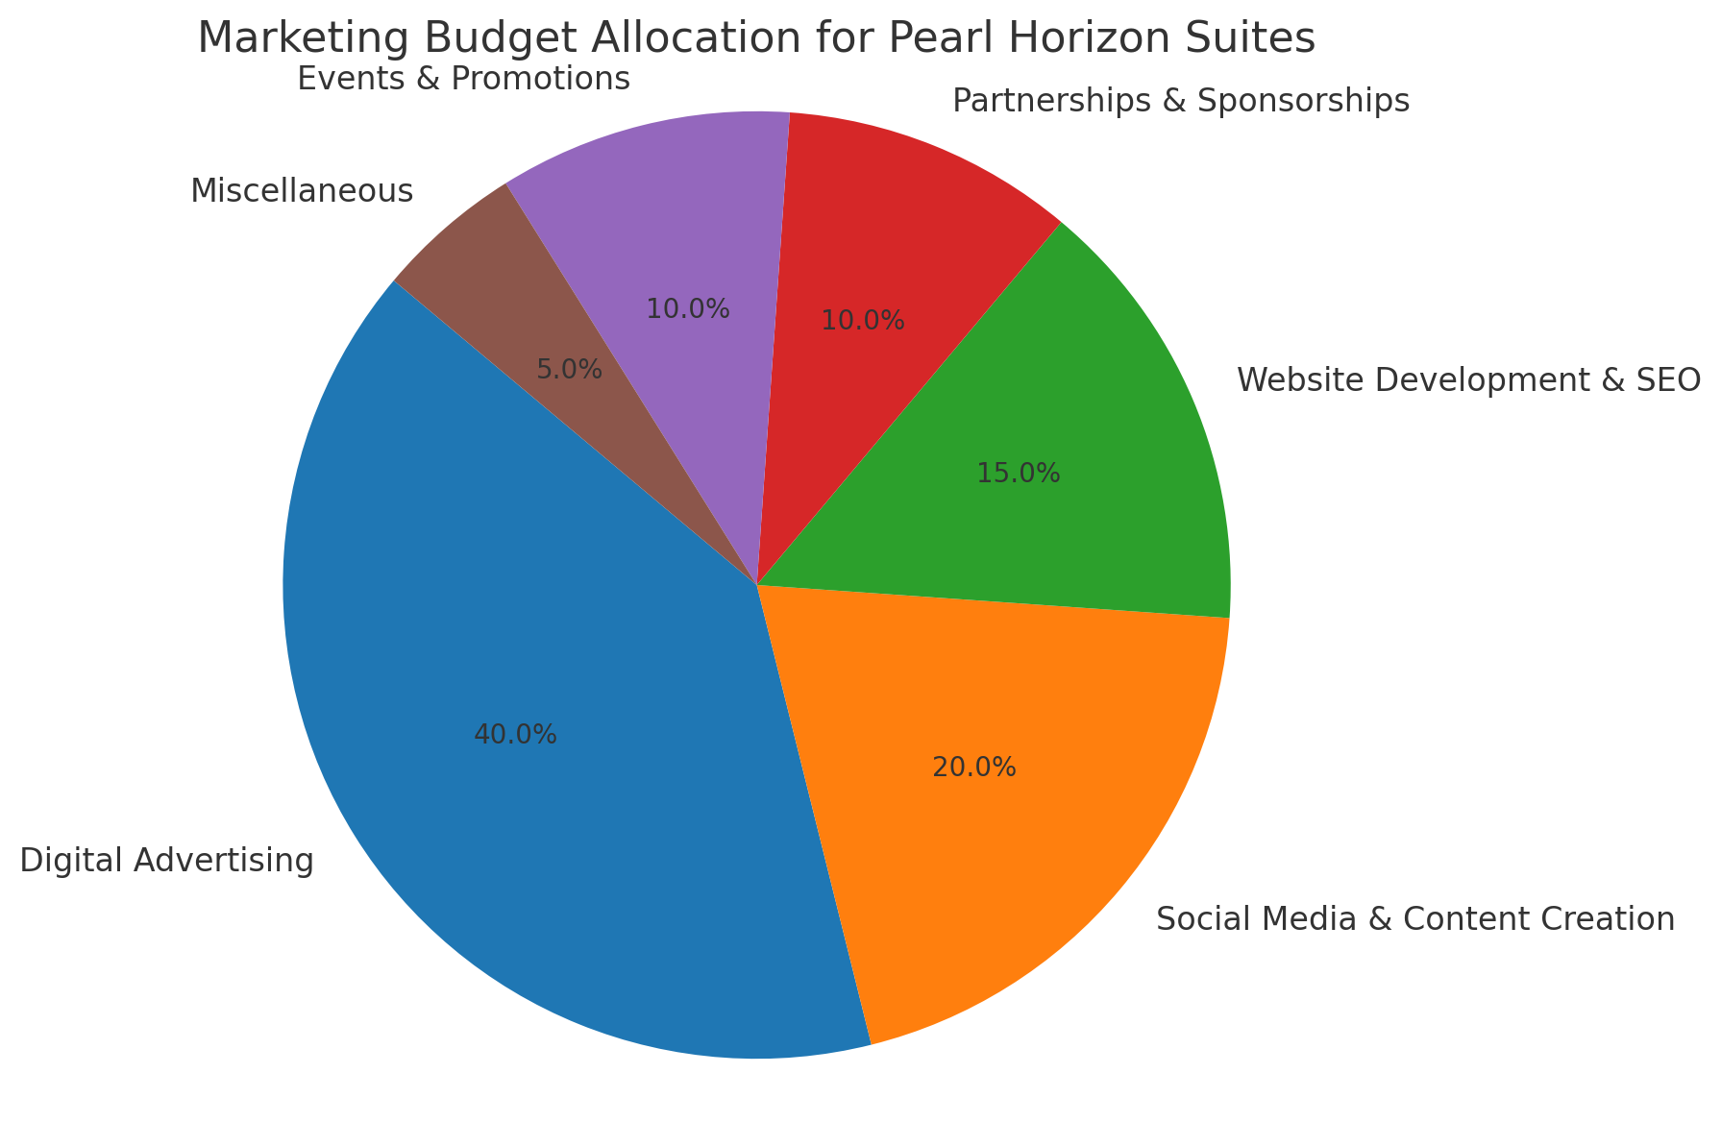

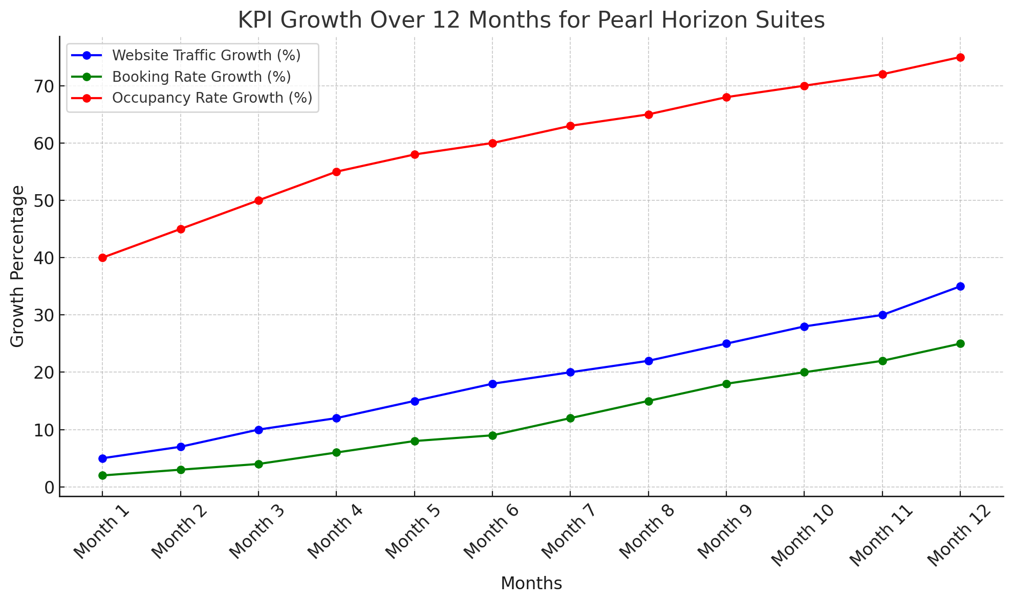

Here are the charts based on the marketing plan for **Pearl Horizon Suites**:

1. **Marketing Budget Allocation**: This pie chart shows the distribution of the marketing budget across different areas. Digital advertising takes the largest share, followed by social media & content creation and website development & SEO.
2. **KPI Growth Over 12 Months**: The line chart demonstrates the expected growth across key performance indicators (KPIs) over a 12-month period:  
   * **Website Traffic Growth**: A steady increase in the number of visitors to the website, peaking by month 12.
   * **Booking Rate Growth**: A gradual rise in bookings as marketing efforts ramp up.
   * **Occupancy Rate Growth**: A consistent upward trend in the occupancy rate as the brand becomes more recognized.

These charts help visualize the marketing strategy’s impact and guide future decisions for improving performance.

***Prompt 5: create a Financial Projections for Pearl Horizon Suites***

Creating financial projections for **Pearl Horizon Suites** involves estimating revenue, costs, and profits based on key assumptions. The projections will cover:

1. **Revenue Projections**
   * **Occupancy Rate**: The percentage of available suites occupied each month.
   * **Average Daily Rate (ADR)**: The average price per suite per day.
   * **Revenue from Different Segments**: Revenue from short-term stays, long-term stays, and corporate clients.
2. **Cost Projections**
   * **Fixed Costs**: These include rent/mortgage, utilities, salaries, and property maintenance.
   * **Variable Costs**: These depend on occupancy levels, such as cleaning services, customer service, and marketing expenses.
   * **Marketing and Advertising**: A fixed monthly budget allocated for ongoing campaigns.
3. **Profit Projections**
   * **Gross Profit**: Revenue minus variable costs.
   * **Net Profit**: Gross profit minus fixed costs.

Let’s break these down in more detail:

### **Assumptions:**

* **Number of suites**: 50 suites
* **ADR (Average Daily Rate)**: $200 per night
* **Occupancy Rate**: Starts at 50% in month 1, increasing by 5% each month until reaching 80% by month 12
* **Monthly Marketing and Operational Costs**: $50,000
* **Variable Costs per Suite**: $30 per night (for services like cleaning, utilities, etc.)
* **Fixed Monthly Costs** (e.g., rent, management salaries): $30,000

Now, I will generate the financial projection table and graph.

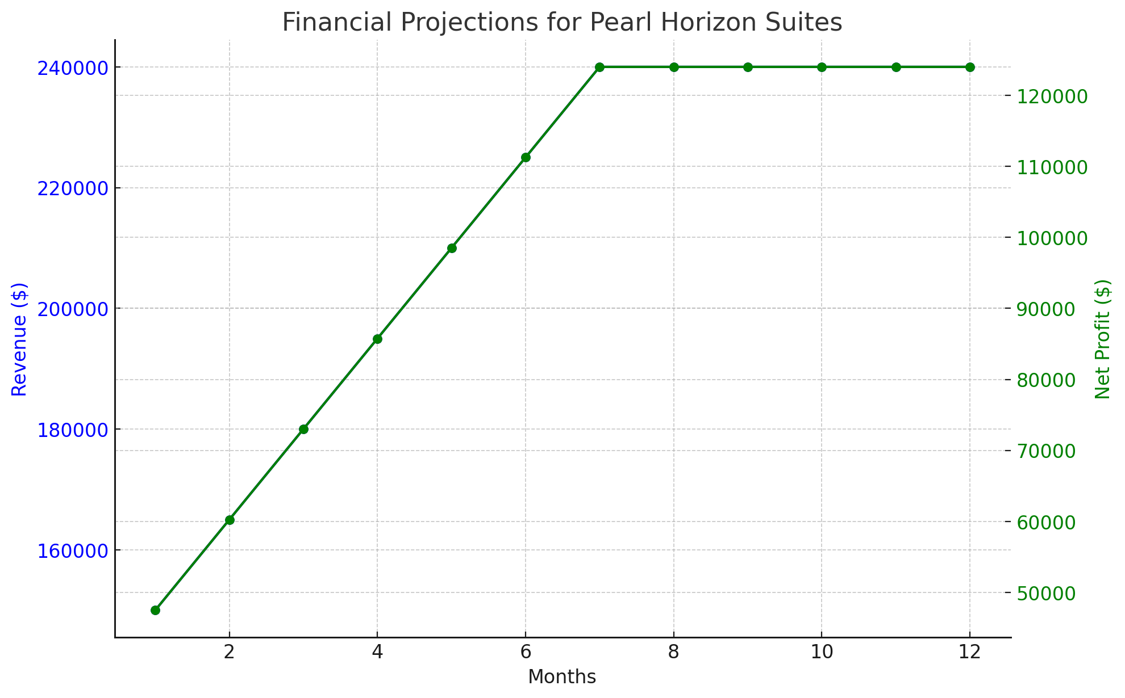

Here are the **financial projections** for **Pearl Horizon Suites** over the next 12 months:

1. **Revenue**: The revenue grows consistently with the increasing occupancy rate, starting at $150,000 in month 1 and reaching $240,000 by month 7. It remains at this level due to the occupancy cap at 80%.
2. **Variable Costs**: These are proportional to the occupancy rate, rising from $22,500 in month 1 to $36,000 from months 7 to 12.
3. **Gross Profit**: The gross profit follows a similar growth trajectory, increasing from $127,500 in month 1 to $204,000 from month 7 onwards.
4. **Net Profit**: After subtracting fixed costs and marketing expenses, the net profit starts at $47,500 in month 1 and steadily increases to $124,000 per month starting from month 7 onward.

The **graph** above also shows the rise in both **Revenue** (blue) and **Net Profit** (green), indicating a positive financial trajectory as the marketing efforts take effect and occupancy grows.

These projections are based on the assumptions provided, and real results may vary depending on market conditions and other factors.